Module 3 Exam Summer 20
Name
Course title
Date

Question 1:
The below figure represents the excess demand labor situation (quantity demanded of labor being greater than the labor supply).
As the labor demand is greater than the labor supply so the workers would bid up their wages to work in a firm/factory. The wages will keep increasing until it reaches the equilibrium level.

Wages ($)

D S

Minimum wages

Excess demand

Labor quantity
Labor works in return for the wages, so if they get higher wages for work they work more, and vice versa.When the factory owner increases the wages of the labour , the labor supply increases as in this case the substitution effect dominates the income effect. If a worker reduces the amount of work despite the higher, then he loses the extra wage.
In this case leisure becomes costly and labor decides to work more. This is the reason that the labor supply curve is upward sloping which means that as the wage rate is increased, the quantity supplied of labor also increases.

D S
Wages ($)

Supply

Minimum wages

Quantity Labor
Question 2
The leakages, household savings, and net tax revenue get injected back into the economy through planned investment spending and the government. Savings leak out to borrowers as it goes through the banking system, and borrowers use the money to buy goods and services, which then injects the money back into the circular flow. Government taxes leak out of the circular flow model, and then government spending injects them back into the economy.
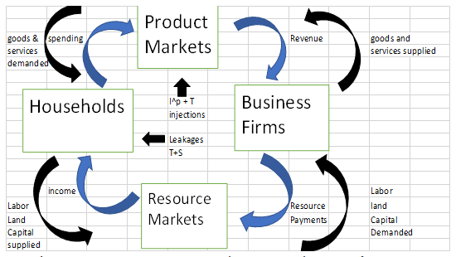
Question 3
Leakages take place when people keep funds with themselves as savings.These savings are issued as loans to some other people or entities and becomes the part of broader market of loanable funds. It makes these savings (as leakages) to come back again in the economy and get utilized. Hence, it is said that market for loanable funds help these savings to come back into the economy.
People save money to get a higher interest rate in the loanable funds market and supply their funds. When leakages go back into the market, then it increases the supply of loanable funds and supply curve shifts to the right. It decreases the interest rate and equilibrium is established. It is in the result of all types of funds (leakages as well as deposits) coming back to the market. It clears the market and prevent people taking undue advantage of higher interest rate in the market.
Question 4 .
The labor market is in equilibrium at E. All the workers willing and able to work are able to find jobs and this implies that currently there is no cyclical unemployment at point E. This also implies that there is full employment or resources and the economy is producing Y1 units of real GDP by using L1 units of labor. Graphical illustration is as shown below:
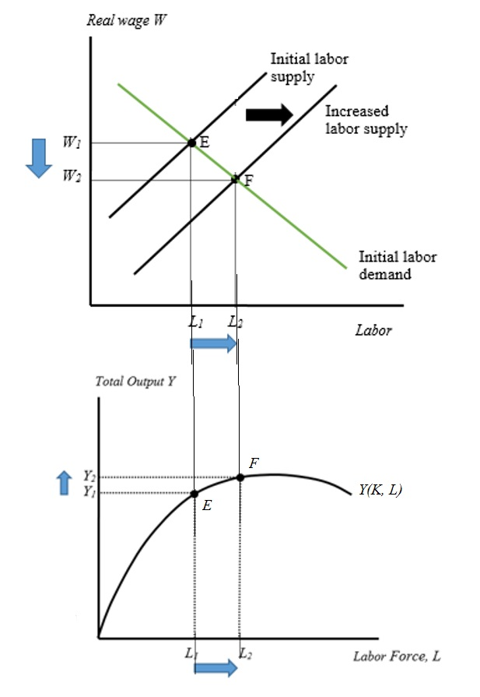
Now there is an increase in labor force participation rate/labor force on the account of immigration. This increases the labor supply so labor supply curve shifts out. The new market wage rate is reduced and the economy moves to F where the new labor units are L2 and increased production at Y2. Thus, we see that immigration has increased the potential output from Y1 to Y2.
Question 5
There are three stages in an aggregate production curve (APC). These are as below:
Stage 1) it is increasing and slops upward as the variable factor (like, worker) increases; it happens because there is increasing return to scale.
Stage 2) it is increasing but at lower rate and slops upward till it reaches the maximum as the variable factor increases; it happens because there is diminishing return to scale.
Stage 3) it is decreasing and slops downward as the variable factor increases; it happens because there is negative return to scale.
APC Curve
Output

Stage 2
Stage 3 APC Curve.

Stage 1

Variable factor (Worker)
Due to these three stages, APC curve is not a 45 degrees straight line. Stage 2 and stage 3 could be eliminated and the curve could be a straight line if there is an equal change in capital or technology. Suppose workers work in a single room and each room must have the maximum capacity to accommodate; if it exceeds production will fall; therefore, another room will be required for increasing production.
Question 6
Labor supply curve is a curve that shows a major tradeoff between labor and leisure and how people’s preference changes to substitute between labor and leisure from time to time.
Two ways the labor supply curve can shift right are:
- Changes in expectations: If people expect their incomes to fall in future, they will work more and will lower their demand for leisure. This will increase the supply of labor and hence the supply curve will shift to the right.
- Changes in preferences: when people substitute more working hours over leisure, they devote most of their time working. This will lead to an increase in the supply of labor and hence the supply curve shifts to the right.

Question 7
Wages S₁
D
S

W₂ ……………………………e₂

W₁ ………………………………………..e₁

L₂ L₁ Labor

As show above, the diagram depict labor Market .In the labor market initial equilibrium occurs at appoint ( e1).Increase in people retiring and not being replaced by young workers will shift the labor supply curve leftwards to L S₁ and new equilibrium occurs at a point E₂ where wage rate has risen and the number of workers employed has fallen.

Output

Y^{1 …………………………………………………………………}

Y^{2 …………………………….}

L₂ L₁ Labor
The fall in the labor employed will reduce total output and National growth rate declines leading to a fall in the standards of living in the Nation.

Question 8
Wages
S
D₁

D

W_{1 ……………………………………………}

W……………………….

L L₁ Labor

Wages

F¹ (L)
………………………………..
Y1 F (L)

Y ………………..

L L¹ Labor
So, Initial production f^{n} was f(L) and L the number of labor with W being wages .When capital/Technology raises, the curve shifts to f¹(L). Output rises causing more demand for labor hence will increase to L¹ with which wages will increase to W¹.
Hence wages raise so will the number of workers output in the economy also raises. Productivity also rise as Y/L is more now. Due to this, the standards of living rises as prices will not rise as wages rise.

